Air-Gapped PC
# Source: AI Source: Provided by: [Data Path: Persons Table -> ID Column: 1, Name_En Column: Motasem Essam] -> From: [ChatGPT] on [1/21/2026]
An Air-Gapped PC Wallet is a highly secure type of cold crypto wallet that involves using a completely offline computer to generate, store, and sign cryptocurrency transactions. The system is called "air-gapped" because it has no physical or wireless connection to the internet or other devices.

🖥️ Key Characteristics of Air-Gapped PC Wallets:
# Source: AI Source: Provided by: [Data Path: Persons Table -> ID Column: 1, Name_En Column: Motasem Essam] -> From: [ChatGPT] on [1/21/2026]
- Offline Computer (Air-Gapped)
  - The device is never connected to the internet (no Ethernet, Wi-Fi, Bluetooth, USB sync).
- Manual or QR-Based Transaction Transfer
  - Transactions are signed offline and then transferred (via QR code, USB, or SD card) to an internet-connected machine for broadcasting.
- High Customization
  - Can run custom wallet software, full node clients, or minimal Linux distributions focused on security.
- Extremely Secure
  - Immune to remote malware, phishing, and keylogging, assuming no initial compromise.

🛠️ How It Works:
# Source: AI Source: Provided by: [Data Path: Persons Table -> ID Column: 1, Name_En Column: Motasem Essam] -> From: [ChatGPT] on [1/21/2026]
- Set up an offline PC with a clean OS (e.g., Linux or Tails).
- Install wallet software like:
  - Electrum (for Bitcoin)
  - Armory
  - Wasabi Wallet (air-gapped mode)
- Generate wallet keys offline and securely back up the seed phrase.
- Create a watch-only wallet on an online computer (to monitor balances).
- When sending funds:
  - Create an unsigned transaction on the online machine.
  - Move it to the air-gapped PC (via QR code, USB, or SD card).
  - Sign the transaction offline.
  - Transfer the signed transaction back online to broadcast.

✅ Advantages:
# Source: AI Source: Provided by: [Data Path: Persons Table -> ID Column: 1, Name_En Column: Motasem Essam] -> From: [ChatGPT] on [1/21/2026]
- Highest level of security when set up properly
- Great for long-term storage of high-value crypto
- Resistant to remote attack vectors
- Flexible and DIY-friendly for security professionals

⚠️ Disadvantages:
# Source: AI Source: Provided by: [Data Path: Persons Table -> ID Column: 1, Name_En Column: Motasem Essam] -> From: [ChatGPT] on [1/21/2026]
- Complex to set up and use (not for beginners)
- Requires dedicated offline hardware
- Risk of user error during transfer/signing process
- Vulnerable if the air-gapped PC is compromised during initial setup (supply chain attacks, infected software)

🧠 Best Use Cases:
# Source: AI Source: Provided by: [Data Path: Persons Table -> ID Column: 1, Name_En Column: Motasem Essam] -> From: [ChatGPT] on [1/21/2026]
- Crypto whales & institutional investors
- Cold storage of very large crypto holdings
- Security-conscious users comfortable with air-gapped systems
- Multi-signature (multisig) offline setups

🆚 Comparison with Other Cold Wallets:
# Source: AI Source: Provided by: [Data Path: Persons Table -> ID Column: 1, Name_En Column: Motasem Essam] -> From: [ChatGPT] on [1/21/2026]
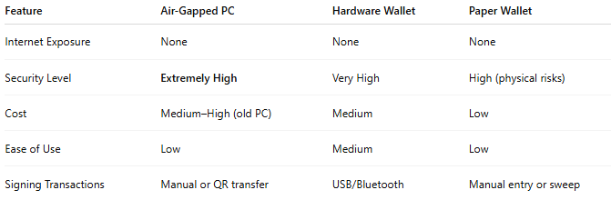

Feature | Air-Gapped PC | Hardware Wallet | Paper Wallet
Internet Exposure | None | None | None
Security Level | Extremely High | Very High | High (physical risks)
Cost | Medium–High (old PC) | Medium | Low
Ease of Use | Low | Medium | Low
Signing Transactions | Manual or QR transfer | USB/Bluetooth | Manual entry or sweep

🔐 Security Tips for Air-Gapped Wallets:
# Source: AI Source: Provided by: [Data Path: Persons Table -> ID Column: 1, Name_En Column: Motasem Essam] -> From: [ChatGPT] on [1/21/2026]
- Use a newly formatted machine with a clean, trusted OS.
- Disable all forms of network hardware and autorun features.
- Verify all wallet software with PGP signatures or checksums.
- Store seed phrase in metal or secure offline form.
- Use one-way data transfer tools (e.g., QR display, unidirectional USB stick).

